8 –FRAME AND FORK ALIGNMENT AND DAMAGE

ABOUT THIS CHAPTER
This chapter has four sections.
The first section is REAR-TRIANGLE ALIGNMENT,
which is designed to be used when there are problems with rear wheel fit, bicycle tracking, or alignment of the front and rear gears.
The second section is FORK-BLADE ALIGNMENT, which is designed to be used when there are problems with front wheel fit or bicycle tracking.
The third section is DROPOUT ALIGNMENT, which is designed to be used in conjunction with either the sections on rear-triangle alignment or fork alignment, or can be used by itself when there are problems with bent axles in hubs.
The fourth section is FRAME AND FORK DAMAGE, which should be used whenever a bike has been in a collision or accident, or as a guide to routine inspection of bicycles for damage as a service to the customer.

GENERAL INFORMATION

TERMINOLOGY
Frame: The structural piece, usually a number of tubes joined together, to which all of the components are attached (the fork is a component).
Rear triangle: The portion of the frame that en- closes the rear wheel, consisting primarily of the seat stays, chain stays, and rear dropouts.
Head tube: The near vertical tube that is the for- ward-most part of the frame.
Seat tube: The near vertical tube that is at the middle of a conventional (non-suspension) frame.
Top tube: The upper tube of the frame that ex- tends back towards the seat from the head tube.
Down tube: The lower tube of the frame that ex- tends from the bottom of the head tube to the bottom of the frame (usually connecting with the bottom- bracket shell).

Bottom-bracket shell: The portion of the frame that contains the crankset bearings, called the bot- tom bracket.
Seat stay: The two tubes of the frame that go from below the seat to the center of the rear wheel.
Chain stay: The two tubes of the frame that go from the lower end of the seat tube to the center of the rear wheel.
Brake bridge: The short piece of tubing joining the two seat stays together just above the rear wheel.
Chain-stay brace: The piece of tubing or flat metal that joins the chain stays together between the bot- tom-bracket shell and the rear wheel.
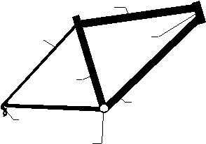
Top tube

Seat stay Head tube

Seat tube
Chain stay Down tube
Dropout
Bottom-bracket shell
8.1 Parts of the frame.
Dropout: The fittings at the juncture of the seat stays and the chain stays, or at the bottom of the fork, that the wheel attaches to.
Axle slot: The slot in the dropout that the hub axle inserts into when mounting the wheel to the frame.
Fork: The structural piece that connects the front wheel to the frame.
Fork column: The tube at the top of the fork that inserts into the head tube of the frame (also called steerer tube, or steering tube).
Fork blades: The two tubes that go on either side of the front wheel.

8 – 1

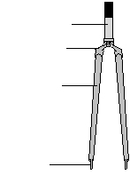
8 – FRAME AND FORK ALIGNMENT AND DAMAGE

Fork crown: The joint, or connecting piece, be- tween the fork blades and the fork column.

Fork column
Fork crown

Fork blade

Dropout
8.2 Parts of the fork.
Hub-over-locknut width: A dimension of the hub measured from the outer face of one locknut on the axle to the outer face of the other locknut. The lock- nuts are the parts of the axle set that butt up against the inside face of the dropouts when the wheel is installed.
Inside-dropout width: The distance between the inside face of one dropout to the inside face of the other dropout.
PREREQUISITES
Wheel removal and installation
Wheel removal and installation are required to align either the fork or the rear triangle.
Rear wheel cog removal
The rear cogs must be removed so that the rear hub can be measured. This measurement is used to align the rear triangle. Depending on the type of hub, either the freewheel will need to be removed or the cogs removed from a freehub.
Crank-arm and bottom-bracket removal and installation
The empty bottom-bracket shell must be held in a jig, or vise, when applying leverage to the rear stays (to align them). The crank arms must be removed to remove the bottom bracket, and must be installed when the bottom bracket is reinstalled.
Headset removal and installation
To align the fork, it is necessary to remove the head- set. This will also require stem removal and perhaps some brake work.

8 – 2

INDICATIONS
Symptoms indicating need for centering the rear triangle or fork blades
There are two types of symptoms that indicate that the rear triangle may need centering, and one of these indicates that the fork blades need centering.
The first type of symptom that indicates either
the rear triangle and/or the fork blades need centering is a problem getting the bike to go in a straight line without undue correction at the handlebars and/or with the rider’s body position. This tracking problem can be caused by many other things, as well, and most of these should be checked before considering or at- tempting rear-triangle or fork-blade centering. Other causes of tracking problems include:
Twisted front triangle Mis-dished wheel(s)
Mis-mounted wheel(s) Mis-aligned fork
Out-of-center rear triangle Damaged or over-tight headset Out-of-true wheels
Extremely loose hub bearings
The other set of symptoms that could indicate that
the rear triangle needs centering is: a problem with
chain noise, or a problem shifting with the front de- railleur. Chainline is affected by rear-triangle alignment, and there are numerous symptoms of chainline error. See the CHAINLINE chapter (page 27-3 and 27-5) for more details about chainline-error symptoms.
The rear triangle or fork blades do not need cen- tering just because there is a measurable centering er- ror. If the error does not create a symptom, then it is a mistake to do an alignment.
Symptoms indicating need for adjusting rear-triangle or fork-blade width
There are two types of symptoms indicating that the rear-triangle or fork-blade width needs to be ad- justed: difficult wheel removal, and difficult wheel in- stallation.
Wheels may be difficult to remove because the axle nuts, or quick release, need to be loosened exces- sively before the wheel will remove easily, or even after adequately loosening the retention device, force is required to get the wheel out of the dropouts. The symptom of excessive loosening of the retention de- vices to make it easy to remove the wheel indicates

8 – FRAME AND FORK ALIGNMENT AND DAMAGE

the width between the dropouts is too great. The symp- tom of difficult wheel removal, even when the reten- tion devices are loose, indicates the width between the dropouts is too narrow.
Wheels may be difficult to install for several rea- sons. The wheel may be difficult to install because the retention device (quick release or axle nuts) needs to be loosened more than was necessary for removal be- fore the wheel will install easily. The wheel may be difficult to install because the wheel requires excessive force to install, even with the retention devices ad- equately loosened. The wheel may be difficult to in- stall because the dropouts require spreading before the wheel will go in easily. When the retention devices need to be loosened more to install the wheel than they needed to be loosened to remove the wheel, it indicates the dropout-inside width is too wide. When the wheel is difficult to install even when the reten- tion devices are adequately loose, it indicates that the dropout-inside width is too narrow.
Dropout-inside width should not be adjusted just because a measurable error exists. There should be a symptom of difficult wheel removal or installation before any fork or rear-triangle alignment is done.
Symptoms indicating need for dropout alignment
The most likely symptom that that indicates that the dropouts need alignment is a bent or broken axle in a hub. A bent axle will cause excess bearing wear.
In extreme cases, mis-aligned dropouts may inter- fere with installation of the wheel.
TOOL CHOICES
Which of the following alignment tools will be needed for a given job is determined by which procedure(s) will be done. The preferred tool choices in the following list (table 8-1) are in bold type. The preference is based on a combination of consider- ations including usability and versatility, economy, and tool quality.

Tool
Park FRS-1

REAR-TRIANGLE, FORK, AND DROPOUT-ALIGNMENT TOOLS (table 8-1)
Fits and considerations
Rigid and functional device for holding the frame at the bottom-bracket shell, comes with inaccurate alignment gauge (needs Park FAG-2 to be more complete)

Park FRS/RSFRS-1 combined with a regular bike stand
Used steel bottom- In conjunction with a high quality vise and heavy duty bench, a good way to hold bracket cups in as- the frame by the bottom bracket sorted thread types
Park FAG-2 Accurately compares relative positions of left and right stays for centering purposes

Park FFS-1 Park SS-1 Stein FCG
VAR 478 Stein FG
Campagnolo H
Park FFG-1 Stein J
Park HTS-1
Leverage tool used for bending rear stays and fork blades Used to straighten stays that have been bowed from impact
Fork alignment jig fits all sizes fork of fork columns. Should be used with Stein dropout alignment tools (available separately, or as part of set). Fork-alignment jig fits all sizes fork columns, not as easy to use as Park FCG-1 Fork-alignment gauge used to check whether fork needs alignment before removing it from bike
Dropout-alignment tools that are adjusted for width by changing washer locations
for a range of 100–135mm in limited steps Dropout-alignment tools that are adjustable infinitely in 82–150mm range Dropout-alignment tools that are adjustable infinitely, clamps very securely by means of QR levers. Calibrated so width can be checked simultaneously. Tool used for pushing head tubes forward that have been pushed back from frontal impact. This procedure is not recommended!

8 – 3

8 – FRAME AND FORK ALIGNMENT AND DAMAGE

COMPLICATIONS
Aluminum, titanium, and composite tubing
Aluminum stays or fork blades should not be bent unless specifically authorized by the frame manufac- turer. Titanium is simply too difficult to bend and should not be attempted. Composites, such as carbon fiber, break before they will bend.
If fit to the wheel is a problem, increase or de-
crease hub width. Wheel fit problems are defined in the preceding INDICATIONS section, under the heading Symptoms indicating need for adjusting rear-triangle or fork- blade width.
If centering is a problem, create a wheel-dish error in the opposite direction.
If chainline is a problem, first attempt to correct the problem at the chainrings (if possible). If this does not work, try shifting spacers from one side of the hub to the other (requiring wheel-dishing corrections).
Aluminum and titanium dropouts
It is generally permissible to align aluminum drop- outs. Titanium dropouts are an unknown at this time.
Excessive misalignment
Whenever the degree of alignment error is high, concerns arise about whether the metal will be fatigued by the amount of bending required. There is no way to quantify this. The greater concern is the number of times the tubing gets bent, rather than the amount that it has or will be bent. Most factory misalignments are not severe enough to be a concern. Modifying rear triangles to accept a hub of 5mm greater width should not be a problem; however, larger corrections, or corrections necessitated by collision damage, are a concern.
Damage
Damage may be present before alignment is at- tempted, or damage may result from excessive attempts to align the stays or fork blades. Inspect before and after every alignment job for cracks, wrinkles, or de- formations in the shape of the tubing.
Unbendable steel tubing
Some steel tubing is so strong that it is virtually unbendable. Oversize fork blades are the most likely candidate for this problem. In this case, there is a dan- gerous risk of bending the fork column while attempt- ing to bend a fork blade. Excessive effort should be avoided.

8 – 4

Suspension forks
Suspension forks cannot be aligned by bending. See the SUSPENSION FORKS chapter (page 38-???) for techniques for alignment of dropouts.
Unbendable dropouts
The design of some dropouts makes them virtu- ally impossible to align. A conventional dropout is basically two-dimensional and “necks-down” (gets nar- rower) between the main body of the dropout and the stays or blade it attaches to. This type can always be aligned.
Some dropouts are not flat two-dimensional plates, but incorporate additional structural material perpen- dicular to the plane of the dropout face. Often this type fits like a plug into a large-diameter end to a fork blade. This type (found on some mountain bikes with rigid forks) cannot be aligned.

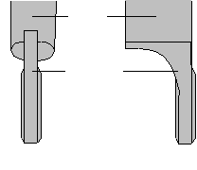
Blade

Dropout

Alignable Un-alignable
8.3 The right dropout/fork-blade style makes dropout alignment
impossible because the dropout is not a narrow plate where it at- taches to the fork blade.
Dropouts or stays/blades first
If stays or blades are aligned first, and then drop- outs, some accuracy to the stay or blade alignment will be lost. If dropouts are aligned first, and then stays or blades, then when the stays or blades are aligned some accuracy of the dropout alignment will be lost.
The normal range of dropout misalignment is not significant enough to have an unacceptable influence on stay or blade alignment, if the dropouts are aligned after the stays or blades. If, doing the alignments in this order, it is found that the dropouts were severely misaligned, then it is necessary to check and correct the stay or blade alignment again, and then the drop- outs again.

8 – FRAME AND FORK ALIGNMENT AND DAMAGE

REAR-TRIANGLE- ALIGNMENT PROCEDURE
Even when symptoms indicate that there is a need to correct width error only or centering error only, a procedure should be used that corrects both. The rea- son for this is that if only one type of error exists it is possible and likely that the other error will be created while correcting the original error.
The following procedure is designed to diminish any existing width error while starting out with a centering-error correction. The procedure is based on the assumption that any width error of more than 1mm would create a symptom. If, after correcting a centering error, the remaining width error creates no symptom (check by installing and removing wheel), then there would be no point in correcting any re- maining width error.

PREPARATION
1. [ ] Use appropriate procedures/worksheets to remove rear wheel, gears from rear wheel, crankset and bottom bracket.
There are two good ways to clamp the frame by
the bottom bracket while performing a rear-triangle alignment.
If a Park FRS or FRS/RS is available, mount the frame to the clamp. This gives a very stable mounting with an unlimited range of adjustments, enabling a comfortable and effective working position.
The alternative is to thread some used steel cups into the bottom-bracket shell (as deeply as possible without recessing the face of the cups in the ends of the shell) and clamp the cup faces into a bench vise. This is adequate and more economical, if your shop is not already equipped with the FRS. A sturdy bench and top quality vise are necessary. The range of adjust- ment to put the frame in a good working position is more limited with this frame-holding technique.
2. [ ] Clamp frame securely by faces of bottom- bracket shell.
INITIAL CONDITIONS
Before making any corrections, it is necessary to know all the existing problems with width error and centering error. Width error is checked by measuring the hub-over-locknut width and comparing it to the dropout-inside width. Centering error is checked with a tool called the Park FAG-2.
The Park FAG-2 is used by putting the adjustable end at the dropout, the end of the flat section (near the curve of the FAG-2) against the seat tube, and the non-adjustable end at the head tube. The adjustable end is then adjusted so that contact is achieved at all three points. When positioning and setting the Park FAG-2, four things should be kept in mind.
The end of the tool at the head tube needs to rest on a flat portion of the tube.
The adjustable end of the tool at the dropout should be positioned so that the tip is on the surface that the axle nut or quick release nut clamps against, preferably at a point close to the juncture of the stays.
The curve of the tool should not be against the seat tube. Extend the indicator further out if the curve of the bar touches the seat tube.
Pressure against the long flat portion of the tool between the seat stay and head tube easily distorts the tool. Hold the tool close to the seat tube to avoid this.
The fact that the procedure starts with setting the FAG-2 on the left side is absolutely arbitrary. A side has to be specified so the words “right” and “left” can be used instead of more awkward alternatives like “the side you started on” and “the side opposite the side you started on.”
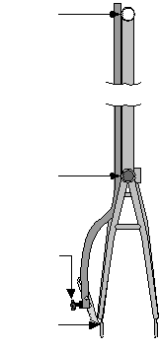
Contact

Contact

Adjust

Contact

8.4 Position the flat portion of the FAG-2 against the head tube
and the seat tube, and the adjustable tip of the tool against the for- ward portion of the surface that the axle nut/quick release nut clamps against.

8 – 5

8 – FRAME AND FORK ALIGNMENT AND DAMAGE

3. [ ] Set FAG-2 to 3-point contact on left side.
When the FAG-2 is transferred to the second side
there may be no gap at the seat tube or right dropout (centering is perfect); a gap might be detected at the dropout that is insignificant; a gap might be detected that is significant; or a gap might be detected at the seat tube (indicating that the procedure should be started over from the other side).
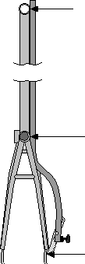
Contact

Gap?

Gap?

8.5 Transfer the FAG-2 to the right side, then check if there is a gap
between the tool and the frame at the seat tube or dropout.

4. Transfer FAG-2 to right side and check one of following choices:
[ ] no gap seen at seat tube or dropout, skip to step 8.
[ ] gap is at right dropout and is <1mm, skip to step 8.
[ ] gap is = 1mm at right dropout, gap measures
______mm, skip to step 8.
[ ] gap is at right side of seat tube (do not mea-
sure), proceed to steps 5–7.
If a gap is detected on the right side of the seat tube, then the procedure should be started over on the right side.
NOTE: Skip to step 8 if any of first 3 lines were checked in step 4.
5. [ ] Only if step 4 resulted in gap on right side of seat tube set FAG-2 to three point contact on right side.
6. [ ] Transfer FAG-2 to left side.
7. Measure gap at left dropout and check one of
following choices: [ ] gap is <1mm.
[ ] gap is ____mm (measure if not <1mm). 8. [ ] Hub-over-locknut width is _________mm.
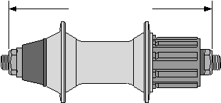
Over-locknut width

8.7 Measure hub-over-locknut width with calipers.

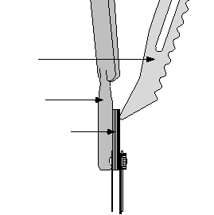

FAG-2

Dropout

Feeler gauges

8.6 To measure the gap between the tip of the FAG-2 and the drop-
out, use a feeler gauge or stack of feeler gauges.
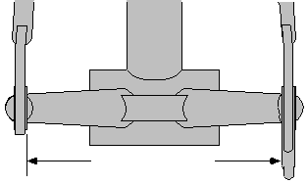
In the next step, when measuring dropout-inside width, to reduce the error created by mis-aligned drop- outs, measure on the surfaces where the hub locknuts touch as close as possible to the juncture of the drop- out to the stays.

Dropout-inside width

8.8 Measure dropout-inside width with calipers.

9. [ ] Dropout-inside width is _________mm.

8 – 6

8 – FRAME AND FORK ALIGNMENT AND DAMAGE

Compare the hub-over-locknut width to the drop- out-inside width to conclude whether the existing drop- out-inside width is wider or narrower than the hub- over-locknut width.
10.[ ] Dropouts are: wide or narrow (circle one).
CENTERING CORRECTIONS
In the next step, whether to bend a stay in or out to correct the centering error is decided. Which stay is best to bend also needs to be decided. If the dropout width is too narrow, then obviously it makes sense to bend a stay out. If the dropout width is too wide, then a stay should be bent in. If bending a stay in, then it should be on the side where the FAG-2 contacted the dropout. If bending a stay out, then it should be on the side where the FAG-2 showed a gap at the drop- out. These choices ensure that width error will not be worsened while correcting the centering error, and will generally be improved. If there is no width error ini- tially, then skip to step #23.
NOTE: Always attempt to bend stays with just hands and start with very low effort on the as- sumption that they will be easy to bend. If they do not respond, then gradually increase effort. If they are too difficult to bend by hand, then use the Park FFS-1 leverage tool on the chain stay to provide greater leverage.
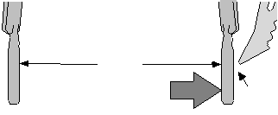

Narrow
Move amount
equal to gap Gap
8.9 This diagram shows centering correction if the dropouts are too
narrow and the FAG-2 shows a gap on the right side.

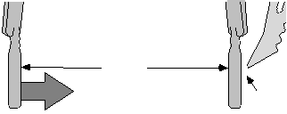

Wide
Move amount equal to gap Gap
Each time a side is bent, it is possible and likely that the other side will move some in the same direc- tion, as well. This is due to the connection between the sides made by the brake bridge and chain-stay brace. When this happens, the point of reference for the FAG- 2 is lost, so it is necessary to reset the FAG-2 each time to check the progress the bend has made. Always reset the FAG-2 on the side where there was no gap ini- tially. This will be the non-bending side if bending a stay out, or the bending side if bending a stay in.
12.[ ] Reset FAG-2 after each bend, as necessary, and check opposite-side gap. (Reset to non- bending side if bending out, reset to bending side if bending in.)
It is unlikely that a final correction will be achieved
in one step. Step #13 suggests that steps #11 and #12 be repeated as many times as necessary to achieve the de- sired tolerance of error, suggested as being a gap at the dropout of less than 1mm.
One possibility is that during one of the bending attempts an over-correction is made, resulting in a gap between seat tube and the FAG-2, after resetting the FAG-2, and transferring it to the second side. If this happens, avoid the confusion that will be created by turning this side into a new reference side. Instead, sim- ply bend the side back that was bent too far and con- tinue using the original side as the reference side for the FAG-2.
13.[ ] Repeat steps 9–12 as many times as neces- sary until final gap is <1mm.
WIDTH CORRECTIONS
To calculate the width error, the current dropout- inside width needs to be subtracted from the hub’s over- locknut width. If the result is positive, then the drop- outs are too wide and the corrections will be accom- plished by moving the sides in. If the result is nega- tive, then the dropouts are too narrow and the correc- tions will be accomplished by moving the sides out.
In the following step, the width error is divided by two to determine the needed correction per side. The correction of the width error has to be split between both sides in order to maintain the centering alignment.
14.Calculate needed correction per side:
over-locknut width _______mm

8.10 This diagram shows centering correction if the dropouts are
too wide and the FAG-2 shows a gap on the right side.
11.[ ] Bend stays:
out? in? (circle one)
on right side? left side? (circle one)
by approx. _______mm (equals FAG-2 gap).
dropout-inside width – _______mm
width error = _______mm
divide ÷ 2
correction per side = _______mm

8 – 7

8 – FRAME AND FORK ALIGNMENT AND DAMAGE

The width correction, therefore, is done in two phases:
•First, either side is bent to achieve the interme-
diate width, the distance halfway between the current width and the hub-over-locknut width.
• Second, the other side is bent the same amount
in the opposite direction to achieve the final width, which is the hub-over-locknut width plus or minus a suggested tolerance of 1mm.
15.Calculate needed intermediate width:
dropout-inside width _______mm
correction per side + _______mm
intermediate width= _______mm 16.[ ] Bend one stay in or out as appropriate to
achieve intermediate width ± .5mm. 17.[ ] Record actual intermediate width achieved
here: ________mm.
18.[ ] Bend other stay in or out as appropriate to
achieve final width (final width is over-lock- nut width ± 1mm).
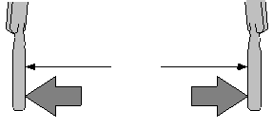

Narrow
A B

8.11 This diagram shows width correction if the dropouts are too
narrow. Move A to achieve the calculated intermediate width and B to achieve the final width. Use the calipers to track progress.
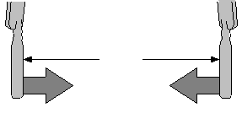
If the acceptable tolerance for centering error has been lost, then there are two approaches to fixing it.
The easiest way, if it will get the job done, is to work with one stay until the width error is just in toler- ance. If the final width is currently narrower than the hub-over-locknut width, then bend the side out that improves the centering error as far as possible without exceeding the maximum acceptable dropout-inside width. If the final width is wider than the hub-over- locknut width, then bend the side in that improves the centering error as far as possible without exceeding the minimum acceptable dropout-inside width. Then check the centering error, which will be better, but perhaps not within the acceptable tolerance.
21.[ ] If centering is out of tolerance and final width is narrower than hub-over-locknut width, bend “gap-side” stays out until width of up to over-locknut width +1mm is achieved.
22.[ ] If centering is out of tolerance and final width is wider than hub-over-locknut width, bend “non-gap side” stay in until width of down to over-locknut width –1mm is achieved.
23.[ ] Use FAG-2 to check whether centering error is = 1mm.
If this approach does not get both within tolerance at once, then use step #24 through step #26 to correct the centering error while maintaining the correct width.
Maintaining correct width
while re-correcting centering error
NOTE: Skip to step 27 if gap in step 23 is = 1mm. 24.[ ] Bend gap-side stays out until width is in-
creased by approximately 1/4 of gap amount. 25.[ ] Bend other side stays in until desired width
is restored.

A

Wide
B

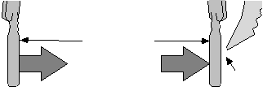

Width correct
B A
Gap

8.12 This diagram shows width correction if the dropouts are too
wide. Move A to achieve the calculated intermediate width and B to achieve the final width. Use the calipers to track progress.
19.[ ] Record actual final width achieved here: ________mm.
Despite all efforts to the contrary, it is not unlikely that the tolerance previously achieved for centering will have worsened to an unacceptable point while correcting the width. Check to see whether this is the case.
20.[ ] Recheck centering error and record here: ________mm gap (tolerance is = 1mm).

8 – 8

8.13 To correct centering error when width is correct, move A
until width is increased by approximately 1/4 of gap amount, and then B until width is restored. Repeat as necessary.
26.[ ] Repeat steps 24–25 as many times as nec- essary to achieve width error of = 1mm and FAG-2 gap of = 1mm.
Finish
27.[ ] Use appropriate procedure/worksheet to align dropouts if desired.
28.[ ] Use appropriate procedures/worksheets to re-assemble bike.

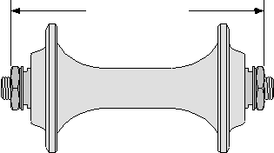
8 – FRAME AND FORK ALIGNMENT AND DAMAGE

FORK-BLADE-ALIGNMENT PROCEDURE
Even when symptoms indicate that there is need to correct only width error or only centering error, a procedure should be used that corrects both. The rea- son for this is that if only one type of error exists it is likely that the other error will be created while cor- recting the original error.
The following procedure is designed to correct both types of error simultaneously. The procedure is based on the assumption that any width or centering error of more than 1mm would create a tracking problems or wheel-fit problem. If, after correcting a centering error, the remaining width error creates no additional symptom(s) (check by installing and removing wheel), then there would be no point in correcting any re- maining width error.
In addition to centering error and width error, fork blades can have a fore-and-aft error. This type of error exists if one dropout is further forward compared to the fork crown than the other dropout.
Although there would be no negative symptoms
if a fore-and-aft error existed without centering or width errors, the existence of a fore-and-aft error can make the wheel appear misaligned to the rider when it is not. It is also inconsistent with good mechanical tech- nique to have the fork out and in the jig to align the width and centering errors, but ignore the fore-and-aft error.
Finally, looking for fore-and-aft error can help iden- tify a fork that has been damaged in a crash or ship- ping. It is normal to see a fore-and-aft error of up to about 2mm. If significantly more error than this is seen, then it is likely that the fork is damaged. The fork should be inspected thoroughly before proceed- ing further.

PREPARATIONS
1. [ ] Use appropriate procedures/worksheets to remove fork from bike.
In the next step, front-hub-over-locknut width is
measured with calipers and recorded. It is not neces- sary, but would be handy if the calipers were locked at this setting until step #16 is completed.

Over-locknut width

8.14 Measure front-hub-over-locknut width with calipers.
2. [ ] Measure front-hub-over-locknut width (front-hub locknut width: _________mm).
Align and secure fork in jig
The Park FCG-1 has three interchangeable clamp- ing blocks for 1", 1–1/8", and 1–1/4" fork columns. The older Park FT-4 fits 1" only, and the VAR 478 fits all sizes without changing blocks.
NOTE: Skip step 3 unless using a Park FCG-1.
3. [ ] Secure correct block inside Park FCG-1 (skip if using Park FT-4).
Depending on the brand and model of fork jig
used in the next step, it is possible to insert the fork column too far into the jig. This is not possible with the Park FCG-1, but with the other models make sure that the clamp of the jig does not go on the fat portion at the base of the fork column, or on the fork-crown race.
Do not secure the clamp at this time. It will be secured in step #8.
4. [ ] Slip fork column into jig until crown race or fork-column base is against, but not inside, jig clamp. Do not secure clamp now!
In the next two steps, the sliding gauge is set so
that it can be used to align the fork in the jig before securing the jig clamp. The sliding gauge is positioned above the fork blades just below the point they join the fork crown (or where the blades begin curving in- ward, if the fork is a unicrown style). The sliding gauge must be secured on the main bar before bringing it down against the fork blades in step #7.
5. [ ] Move sliding gauge to position that will con- tact fork blades just below fork crown.
6. [ ] Secure sliding gauge.
7. [ ] Swing main bar down until sliding gauge is
firmly against both fork blades.
With the sliding gauge positioned and secure, and

the fork still loose in the clamp, applying pressure down on the main bar will automatically bring the

8 – 9

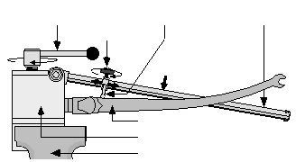
8 – FRAME AND FORK ALIGNMENT AND DAMAGE

fork into proper rotational alignment. Maintain the downward pressure while securing the fork clamp in the next step.
It is easy for the fork to slip in the clamp while bending the blades, so get the clamp as tight as pos- sible. The design of the clamp mechanism insures that the fork column will not be crushed.

11.[ ] Check with feeler gauge(s) to see if gap at other end of sliding gauge exceeds 1mm.
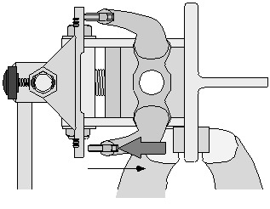
12.[ ] If gap exceeds 1mm, turn jig in vise so that one side-mounting plate is in vise.

Fork clamp Sliding-gauge clamp Sliding gauge Main bar

Vise

8.17 Turn the jig on its side to bend fork blades fore-and-aft.
8. [ ] While holding main bar firmly down, secure fork clamp. NOTE: Always attempt to bend blades with just hands and start with very low effort on the as- sumption that they will be easy to bend. If they
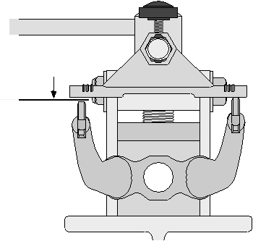
do not respond, then gradually increase effort. If they are too difficult to bend by hand, then
use the Park FFS-1 leverage tool with a conser- vative effort initially.
13.[ ] Using the FFS-1 only if necessary, bend one blade until difference at each end of sliding gauge is <1mm.
14.[ ] Move sliding gauge back to just below fork crown, secure, and check that there is still two-point contact when the sliding gauge is
swung down to contact the blades. Reset fork in jig as necessary to re-establish two-
point contact.

8 – 10

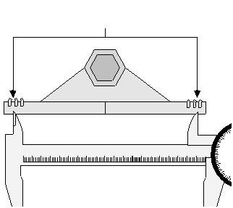
8 – FRAME AND FORK ALIGNMENT AND DAMAGE

In the next step, do not mark the diagram on this page. Instead, mark the diagram on your photocopy of page WORKSHEETS – 10.
16.[ ] Mark on below diagram of sliding gauge points where caliper tips end up when cen- tered:

Mark diagram on worksheet at points caliper tips line up

Set caliper to equal over-locknut width, then center caliper to diagram .8
.7
.6
! " # $ % & '
.5
.4
.3
.2

DROPOUT-ALIGNMENT PROCEDURE
If performing dropout alignment before fork-blade
or rear-triangle alignment, then dropout alignment may need to be redone. This is certainly the case if fork blades have been aligned in the fore-and-aft respect.
If performing dropout alignment after fork-blade or rear-triangle alignment, then fork-blade or rear-tri- angle alignment may need to be redone after the drop- out alignment. This is only likely if the dropouts were found to be severely misaligned.
All brands of dropout-alignment tools have a fat spacer washer 10–13mm thick that goes outside the drop- outs on front dropouts and inside the dropouts on rear dropouts. When securing the dropout-alignment tools to the dropouts, make sure that they are fully inserted and do not squirm out of position while being secured. They do not need to be secured very tightly.
1. [ ] Insert tools in dropouts and secure.
The alignment cylinders should be as close to each

8.18 In this example, the caliper is set to the over-locknut width
and centered to the sliding gauge lines up between the middle and outer ridges on each end of the sliding gauges, so sliding-gauge dia- gram on your photocopy of page WORKSHEET – 10 should be marked to reflect this.
Align blades to correct width and center
17.[ ] Align each blade so that inner face of each dropout ends up directly in line with points on sliding gauge marked on sliding-gauge diagram.
18.[ ] Measure dropout-inside width: ________mm. 19.[ ] Difference between over-locknut width and
dropout-inside width is: _____________mm. 20.[ ] If difference is = 1mm, alignment is done. 21.[ ] If difference is > 1mm, move both blades in
or out equally until difference is = 1mm.
The force of aligning the blades can cause the fork column to twist in the clamp. In the next step, whether this has happened is checked, and if two-point contact with the sliding gauge is not still occurring at the top of the fork blades, then the fork needs repositioning and the alignment should be redone.
22.[ ] Make sure fork is still aligned in jig correctly when all blade alignments are done. If not, reset fork in jig and repeat steps 17–22.
23.[ ] Use appropriate procedure/worksheet to align dropouts if desired.
24.[ ] Use appropriate procedure/worksheet to in- stall fork and stem.
other as possible without touching. With Park FFG-1 tools, simply rotate the alignment cylinders so that they thread closer or further apart as needed. With Campagnolo H tools, shift washers from one face of the dropout to the other to adjust spacing. For fine- tuning the Campagnolo H tools, 1mm rear hub axle spacers can be added to the tool on either of both sides.
2. [ ] Adjust so that alignment cylinders are close but not touching.
There are two types of misalignments that will be
seen at the ends of the alignment cylinders. These will be called offset and gap spread. Both of these misalignments need to be checked from two perspec- tives: viewed from in front and from above.
Offset is when one cylinder edge is offset to the closest edge of the other cylinder. The following illus- trations show simple offset error (figure 8.19) and com- bined offset and gap-spread error (figure 8.20).

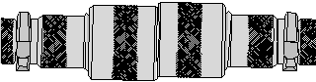

8.19 Simple offset error.

8 – 11

8 – FRAME AND FORK ALIGNMENT AND DAMAGE

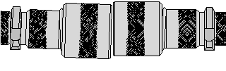
Gap spread should only be corrected when there is no offset error. The below illustration shows a simple gap-spread error.

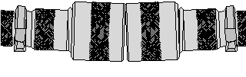

Gap and offset
8.20 Offset error and gap-spread error combined.

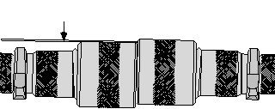
When offset error is slight, check whether it is tolerable by placing a .5mm feeler gauge on the lower cylinder. If the top of the feeler gauge is even with the other cylinder or above the other cylinder, offset er- ror is in tolerance.
.5mm feeler gauge

8.21 Use a feeler gauge to check whether the offset error is in toler-
ance. This example shows unacceptable offset error because the offset is more than .5mm.
Correct offset by applying leverage to one tool handle only, until offset is reduced to acceptable. If there is also a gap-spread error, it is possible to correct offset in a direction that also reduces gap-spread error. If there is no gap-spread error initially, correcting off- set error will introduce gap-spread error unavoidably.
Gap
8.23 Simple gap-spread error.
To measure a gap-spread error, adjust the alignment cylinders until they are just touching (Park FFG-1) and use a feeler gauge to measure the gap at the widest point. Less than or equal to .5mm is good. With Campagnolo tools, the alignment cylinders cannot be set to contact, so use a feeler gauge at the closest and widest points and calculate the difference.
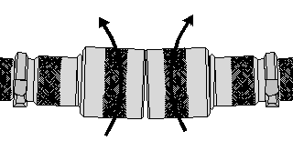
The easiest way to fix a gap-spread error is to grab both tool handles simultaneously and bend them the same direction the same amount at the same time. If they don’t bend equally, then a slight offset error will be created, which can be corrected after the fact.

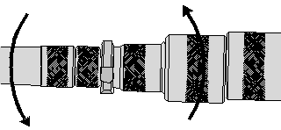
8.24 Fix a gap error by applying leverage to both tools at once, in
the same direction.

8.22 Correct offset error by applying leverage to one tool only un-
til error is reduced to acceptable.
3. [ ] If offset between cylinders viewed from in front exists, bend one side to reduce offset to .5mm or less.
4. [ ] If gap spread (viewed from in front) is not in tolerance from top to bottom, bend both sides equally in same direction until gap- spread difference is .5mm or less.
After eliminating offset and gap-spread errors evi-
dent when viewing the alignment cylinders from in front, the process needs to be repeated viewing the alignment cylinders from a viewpoint 90° away, such as from directly above.
5. [ ] If offset between cylinders viewed from above exists, bend one side to reduce offset to .5mm or less.
6. [ ] If gap spread (viewed from above) is not in tolerance from front to back, bend both sides equally in same direction until gap- spread difference is .5mm or less.

8 – 12

8 – FRAME AND FORK ALIGNMENT AND DAMAGE

It’s quite possible that the alignment tools have shifted in the dropouts during all the bending. In the next step, they are loosened and re-installed to check if the adjustments are still good.
7. [ ] Loosen and resecure both tools.
It is easy to mess up the original alignments while
doing the second set. Steps #8 and #9 have you recheck everything.
8. [ ] Check and repeat steps 3 & 4 if necessary. 9. [ ] Check and repeat steps 5 & 6 if necessary.
10.[ ] Recheck rear-triangle or fork-blade alignment if dropout misalignment was severe.

FRAME AND FORK DAMAGE

TWISTED FRONT TRIANGLE
When a front triangle of a frame is twisted, the head tube is not in the plane of the seat tube. Since the front wheel is in the same plane as the head tube and the rear wheel is in the same plane as the seat tube, the two wheels are in different planes. When the wheels are in different planes, the bike will have a tendency to pull to one side.
Identifying a twisted front triangle
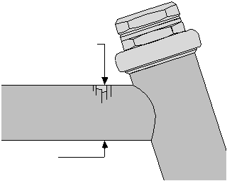
The key to identifying a twisted front triangle is knowing when to look for it, since it is not usually obvious during casual observation. Lateral impact to the front end is what does the damage. This impact is not directly to the head tube but through the wheel and fork, or through the handlebars. When fork blades are bent dramatically to the side or handlebars are crushed from the side, it is time to inspect for a twisted front triangle.
To inspect, put the bike in a bike stand so that the seat tube is vertical, rather than laid back. Put a mag- netic base angle finder on the side of the head tube and the side of the seat tube. Ideally, these two should be identical. If the angles are different by less than one degree it should be no problem. More than one degree of difference probably indicates damage, and two or more degrees is a certain indicator of damage.
Repair of twisted front triangles
There are two approaches to repair a twisted front triangle, neither of which would be considered stan- dard shop operating procedure.
Using a frame builder’s frame table, it is possible to insert a leverage bar into the head tube and twist it back. This is not recommended because the original damage
meant that either the down tube or top tube became twisted over its length. Twisting the head tube will not untwist the damaged tube; it will simply twist another tube in an offsetting direction. The result is a frame that ends up stressed and unstable.
A frame builder can repair the damage by replacing the top tube or down tube, as necessary. This is rarely financially feasible, and is certainly a job for a profes- sional frame builder and not a bicycle repair shop.
BUCKLED DOWN TUBE AND TOP TUBE
Frontal impact can easily buckle the top tube and/ or the down tube. This type of damage is not obvious through casual observation, but is easily spotted if the correct warning signs are known.
Identifying buckled down tubes and top tubes
Down tubes and top tubes become buckled dur- ing any type of frontal impact. This impact usually damages the fork in some way, either bending the blades back or the fork column back. Anytime either of these conditions are detected, the down and top tubes should be inspected for buckling.
Even when there is no apparent fork damage, there are some good warning signs to look for. When tubes are buckled, it usually damages the paint on the tube directly opposite the buckle. Any cracks or chips in the paint on the top of the down tube or top tube directly behind the head tube are signs that the tubes have been flexed severely and probably have buckled.

Chips and cracks here

Inspect here

8.25 Paint cracks indicate the top tube may be buckled. Inspect
opposite the cracks for any bulge or deformity.

8 – 13

8 – FRAME AND FORK ALIGNMENT AND DAMAGE

On the underside of these tubes, directly behind the head tube, is where the buckling would be found. Any bulge or deformity in this area means the tube is buckled.
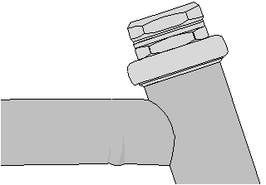

8.26 The bulge on the bottom side of this tube indicates it is dam-
aged from frontal impact.
Repair of buckled down tubes and top tubes
The obvious consequence of this type of damage
is that the head-tube angle is steeper and the front wheel has moved further back, often so much so that the rider’s feet or the pedals or crank interfere with the front wheel when it is turned to the side. The Park HTS-1 is designed to push the head-tube angle back, but it does not repair the damage.
The real problem with these buckled tubes is not the change of head-tube angle, but the buckling itself, which causes a stress riser in the tubing. A stress riser is an irregularity in a structural piece that causes stress to localize in the area of the irregularity, rather than distribute more evenly over the entire piece. This con- centration of stress leads to premature metal fatigue and ultimately leads to failure.
The only legitimate repair, consequently, is to have the damaged tubes replaced by a framebuilder. This option is rarely financially sensible.
When buckled tubes are detected, always advise the customer the bike is unrideable and unrepairable.
FRAME AND FORK FATIGUE CRACKS
Fatigue cracks can occur at any time, anywhere in a metal structure. They are most likely to occur in the areas of highest stress, but poor design or construc- tion technique can lead to cracks in relatively unstressed areas.

8 – 14
The optimum time to inspect for fatigue cracks is any time the frame is being cleaned.
What is most consistent about fatigue cracks is that they almost always occur near joints. The in- spection should focus on all the joint areas of the frame and fork:
anywhere the design of the frame creates a stress riser
anywhere damage to the frame or fork creates a stress riser
on or near the dropouts anywhere on the head tube both ends of the down tube bottom of the seat tube
front end of the chain stays all around the seat lug
top end of the fork blades
where the fork column enters the fork crown
Fatigue cracks often just appear as paint cracks; however, not all paint cracks indicate metal fatigue. Chip away cracked paint to inspect for cracks in the metal below, particularly if the cracked paint is in one of the areas listed above.

DENTED TUBES
The location and severity of a dent in a tube deter- mines the extent of the problem. A dent near a joint is more of a concern then somewhere near the middle of a tube. A dent with a crease is far worse then a dent without a crease. Dents with creases or near a frame joint are likely locations for fatigue cracks.
There is no reason to repair a non-significant dent except cosmetics. The technique for removing the dent will damage the paint and also require the use of a filling compound to completely eliminate the dent. Unless prepared to go as far as a paint job, there is no point in trying to reduce or eliminate dents in tubes.
Critical dents cannot be repaired except by tube replacement by a framebuilder, which is rarely finan- cially sensible.
BOWED STAYS
Bowed stays are an uncommon form of damage, which can look quite severe, but are actually very re- pairable. Typically it is the seat stays that are bowed, but occasionally the chain stays.
A bowed stay is displaced from its normal path in a gradual curve. Sharp bends or wrinkled tubing fall under the category of severely dented tubing and are not repairable.

